ESCOLA SECUNDÁRIA EÇA DE QUEIRÓS
Departamento de Língua Estrangeira
English

HOLIDAYS - LEISURE / SPORTS (Speaking Activity) Teacher: Teresa Rafael
Name :Pedro Aurélio Class: S - 13


What would you rather do than the rest?
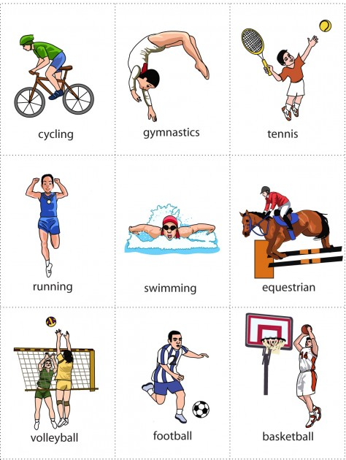

Follow the example:
I would rather play volleyball than play basketball. And you? What would you rather play?
I would rather ....

